----------------------------------------------------- HOURS

Team Member  First Last | Hours  this Week | Total Hours  since Aug 19 | Signature  you verify that hours of all team members are reported truthfully
Trace Shafer | 10 | 162.5 | Trace Shafer
Ben Sherman | 10 | 166.5 | Ben Sherman

----------------------------------------------------- TIMELINE
Design Review | Expected Presentation Date | Status | Completion Date
Conceptual Design Review | 9/4/2024 | COMPLETED | 9/4/2024
Preliminary Design Review | 11/8/2024 | COMPLETED | 11/8/2024
Critical Design Review | 12/9/2024 | COMPLETED | 12/9/2024
Test Readiness Review | 2/14/2025 | IN PROGRESS
Test Results Review
Improvement Review
Final Review
Exhibition

----------------------------------------------------- ACTION REPORT

Team Member  First Last | Action Report  List actions taken this week towards your in-progress review. Give details using Research & Analyze, Design, Prototype, Test, and Report.
Trace Shafer | Research and Analyze  - Continued to meet with Dr. Eves about our simulation code.  - Dr. Eves wrote a control code and gave us some helpful tips from it to implement into our code.  - Changed the code for the calibration of the star tracker camera. The problem is that when we print it out, the margins are off.  - Met with Professor Schiller about machining our reaction wheel mounts. A couple small things need to get changed but he was very satisfied with our design.  - Printed out air bearings for testing.  - 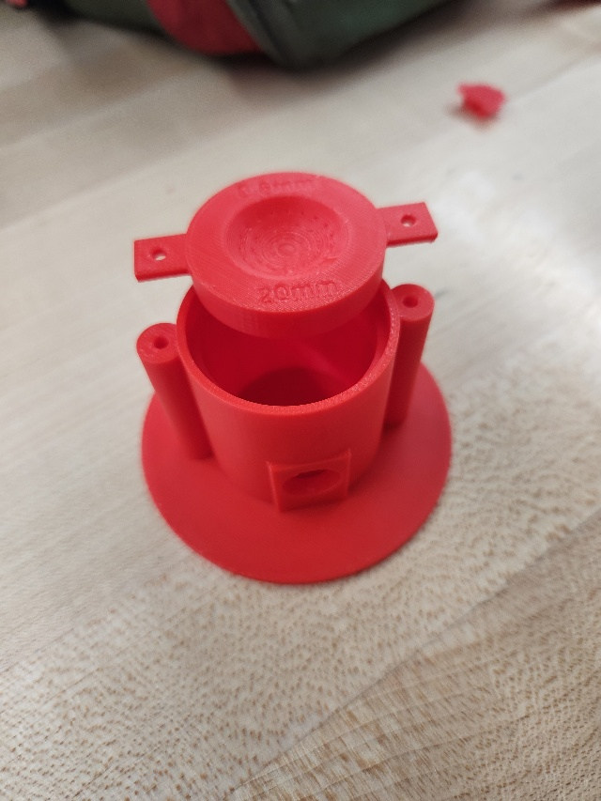  Report  - Started copying over slides from CDR to Delta CDR.
Ben Sherman | Research & Analyze  - Talked to Dr Eves about using a new way to control CubeSat. He talked about converting our quaternions to Euler angles to Modified Rodrigues Parameters.  - 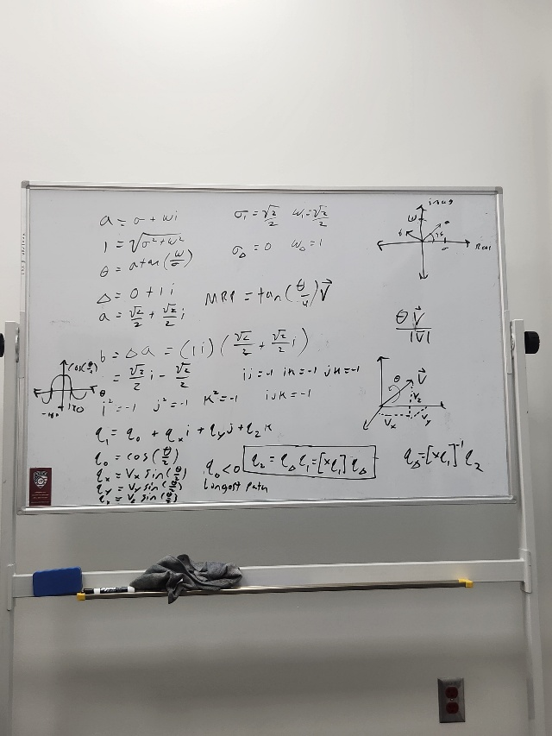  - Worked on implementing Dr Eves suggestions to the code  Report  - Working on test readiness review

----------------------------------------------------- ACTION PLAN

Team Member  First Last | Action Plan  List actions you plan to take this week towards your reviews. Give details using Research & Analyze, Design, Prototype, Test, and Report.
Trace Shafer | Research & Analyze  - Continue to work on the simulation implementing the changes suggested by Dr. Eves.  - Find a way to fix the margins from printing over the web for camera calibration.  Design  - Change the design of the reaction wheels mount. Minor changes include making it smoother.  - Print out the new design.  Report  - Go over the slides again for Test Readiness Review
Ben Sherman | Research & Analyze  - Improve the code we are using, make sure LQR is working properly and then add EKF  - Implement Modified Rodrigues Parameters into code  Test  - Design and 3D print test fixtures  Report  - Start working on Test Readiness Review

